FS80 Bracket

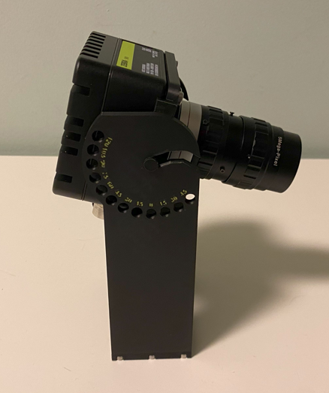

Project Goals
Create a support bracket than can simplify the test of an FS80.
The bracket is not intended for field installation but only for short term lab test.

Mounting Drawings
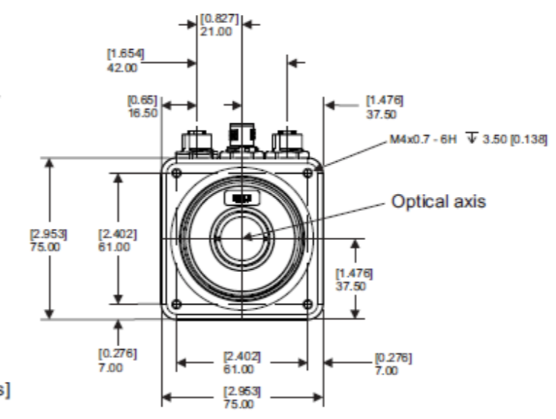

Design

FS80 Bracket
Mounting Screws: 4x 4 mm diameter / 6 mm length

Support Pin: Diameter 5.8 mm, height 7 mm

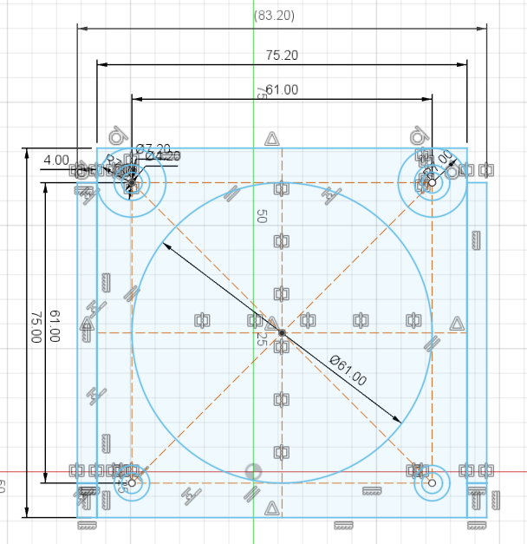
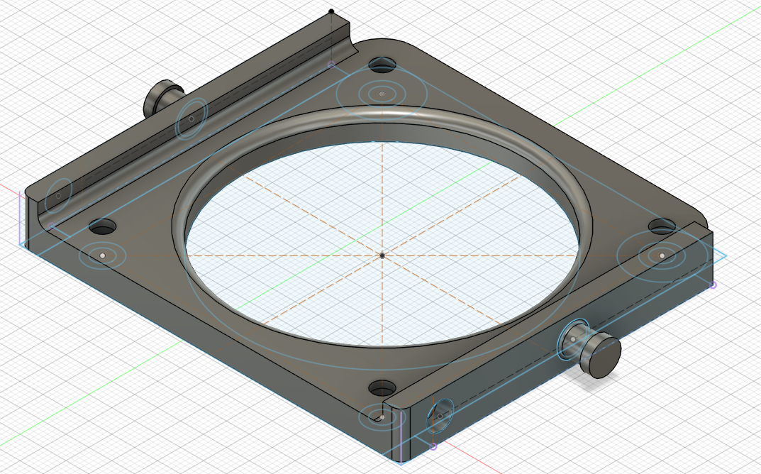

FS80 Shoulder
Center slot 6 mm
Locking screw: 6 mm x 10 mm dept
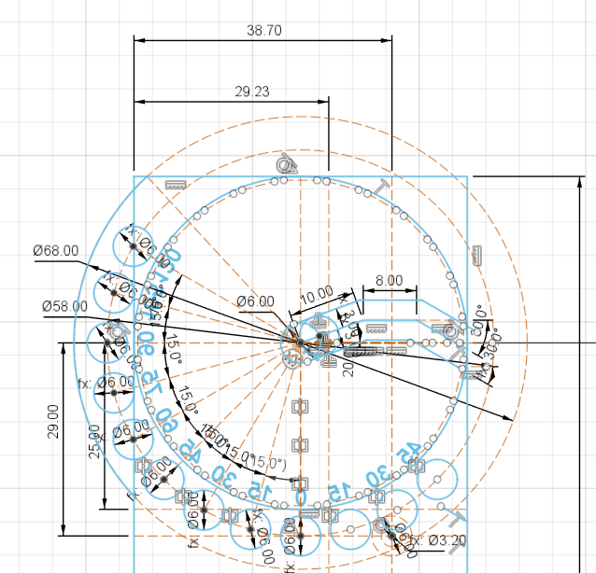 | 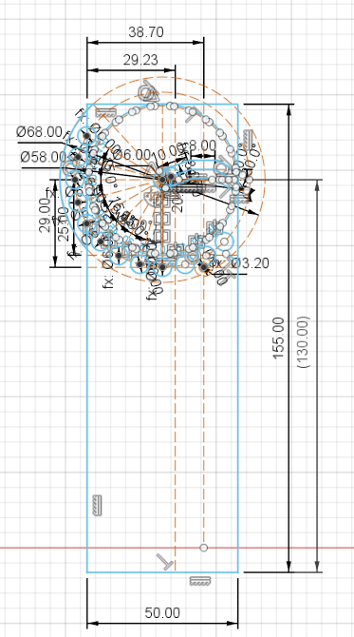

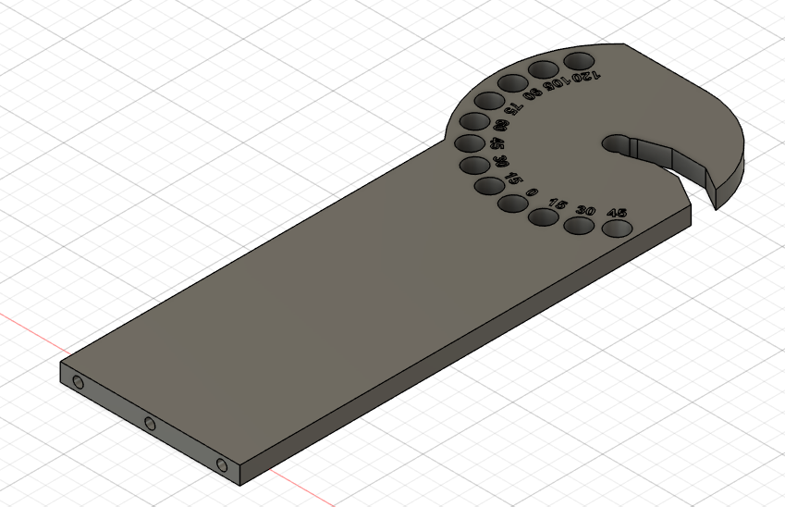

We need 2 of this shoulder.

FS80 Bracket Base
Mounting screws: 6x 3 mm diameter x 16 mm long
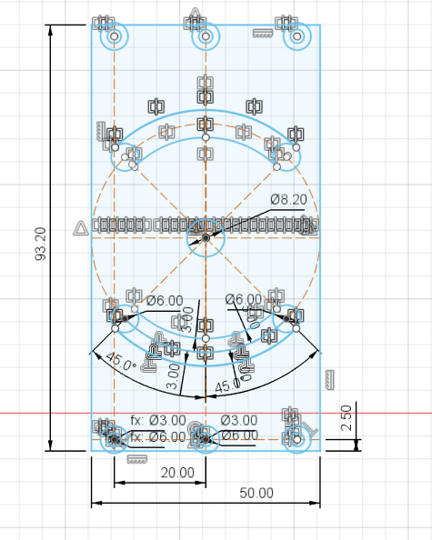
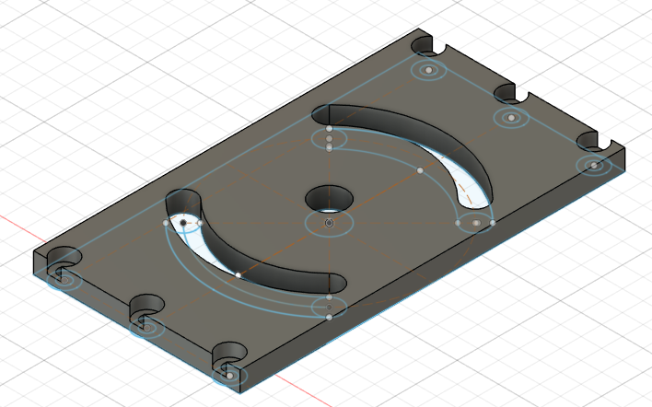

Components Pictures

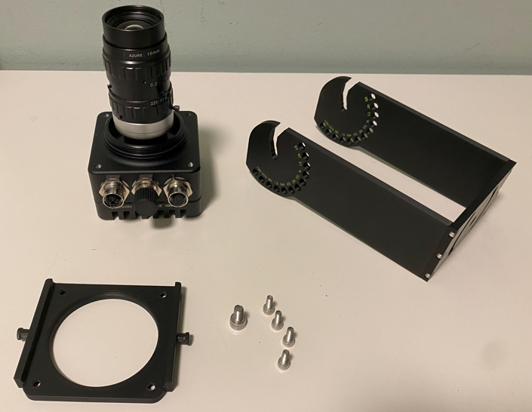

For Next iteration
Temperature resistance of the bracket need to be validated.
Maybe a different connection between the camera body and the flange can shield the bracket for excess temperature.
The text in the graduation area has a poor readability. Try to double the size and use only half number of labels.
